Giving Birth to Christ

From: Richard Rohr - Daily Meditations Advent 2020

From the Center for Action and Contemplation

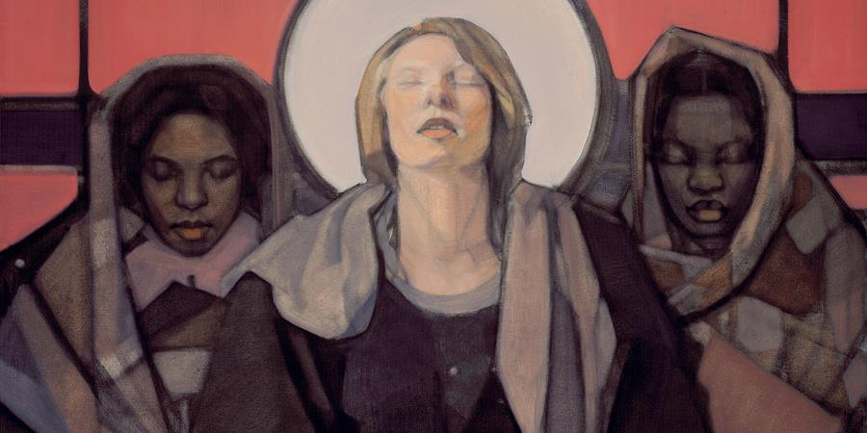

Christ Is Born in Creation
Monday, December 7, 2020

Humanity too is God’s creation. But humanity alone is called to co-operate with God in the creation. —Hildegard of Bingen
For of his fullness we have all received, grace upon grace. —John 1:16
The Greek word for “fullness” in this gospel passage is pleroma, which Paul also uses in his writings to describe a historical unfolding (see Ephesians 1:23, 3:19; Colossians 2:9–10). It is an early hint of what we now call evolutionary development, the idea that history, humanity and, yes, even God are somehow growing and coming to a divine fullness. What hope and meaning this gives to all life!
In his letter to the church in Rome, Paul writes: “From the beginning until now, the entire creation, as we know, has been groaning in one great act of giving birth” (Romans 8:22). Creation did not happen at once by a flick of the divine hand, and it is not slowly winding down toward Armageddon or tragic Apocalypse. Creation is in fact a life-generating process that’s still happening and winding up! We now know the universe is still expanding—and at an ever-faster rate, which means that we are a part of creating God’s future.
As Sister Ilia Delio *** says so well,
We can read the history of our 13.7-billion-year-old universe as the rising up of Divine Love incarnate, which bursts forth in the person of Jesus, who reveals love’s urge toward wholeness through reconciliation, mercy, peace, and forgiveness. Jesus is the love of God incarnate, the wholemaker who shows the way of evolution toward unity in love. In Jesus, God breaks through and points us in a new direction; not one of chance or blindness but one of ever-deepening wholeness in love. In Jesus, God comes to us from the future to be our future. Those who follow Jesus are to become wholemakers, uniting what is scattered, creating a deeper unity in love. Christian life is a commitment to love, to give birth to God in one’s own life and to become midwives of divinity in this evolving cosmos. We are to be wholemakers of love in a world of change. [1]
The common Christian understanding that Jesus came to save us by a cosmic evacuation plan is really very individualistic, petty, and even egocentric. It demands no solidarity with anything except oneself. We whittled the great Good News down into what Jesus could do for us personally and privately, rather than celebrating God’s invitation to participate in God’s universal creative work.
Instead of believing that Jesus came to fulfill us separately, how about trusting that we are here to fulfill Christ? We take our small but wonderful part in what Thomas Merton calls “The General Dance.” [2] We are a part of this movement of an ever-growing Universal Christ that is coming to be in this “one great act of giving birth” (Romans 8:22).
*** Note (a Fransiscan Sister of Washington DC, google her – interesting) .K

Receiving the Gift
Tuesday, December 8, 2020

Why, from the earliest centuries, have Christian people been so excited about Mary? What’s happening in the depths of our soul when we hear her story? Surely it must be about more than the miracle of the virgin birth. As Benedictine oblate, author, and poet Kathleen Norris shares, Mary’s “virginity” has less to do with biology than with her stance towards God and life itself.
It’s in the monastic world that I find a broader and also more relevant grasp of what it could mean to be virgin. Thomas Merton, in Conjectures of a Guilty Bystander, describes the true identity that he seeks in contemplative prayer as a “point vierge” [virgin point] at the center of his being, “a point untouched [by sin and] by illusion, a point of pure truth . . . which belongs entirely to God. . . .” [1]
It is only when we stop idolizing the illusion of our control over the events of life and recognize our poverty that we become virgin in the sense that Merton means. . . . We all need to be told that God loves us, and the mystery of the Annunciation reveals an aspect of that love. But it also suggests that our response to this love is critical. A few verses before the angel appears to Mary in the first chapter of Luke’s Gospel, another annunciation occurs; an angel announces to an old man, Zechariah, that his equally aged wife is to bear a son who will “make ready a people prepared for the Lord.” The couple are to name him John; he is known to us as John the Baptist [Luke 1:11–18]. Zechariah says to the angel, “How will I know that this is so?” which is a radically different response from the one Mary makes. She says, “How can this be?”
I interpret this to mean that while Zechariah is seeking knowledge and information, Mary contents herself with wisdom. . . . Mary’s “How can this be?” is a simpler response than Zechariah’s, and also more profound. She does not lose her voice but finds it. Like any of the prophets, she asserts herself before God, saying, “Here am I.” . . . Mary proceeds—as we must do in life—making her commitment without knowing much about what it will entail or where it will lead. I treasure the story because it forces me to ask: When the mystery of God’s love breaks through into my consciousness, do I run from it? . . . Or am I virgin enough to respond from my deepest, truest self, and say something new, a “yes” that will change me forever? [2]
If Jesus is the representative of the total givenness of God to creation, then perhaps Mary is the representative of humanity, showing us how the gift is received. And I believe that is why we love Mary. She’s a stand in for all of us. When we can say, like her, “Let it be,” then we’re truly ready for Christmas.

After further reflection, the Daily Meditations editorial team has decided to substitute a new image for this week's theme. In our original choice, Mary appears white and is in the center of the image, while the two women adjacent to her are black. We recognize the historic centering of whiteness in Western art and religion, and we strive to use images in the Daily Meditations that disrupt this legacy. Together, we are developing, growing, and changing for the good—towards an ever more inclusive love in Christ. (The Universal Christ, 95)​

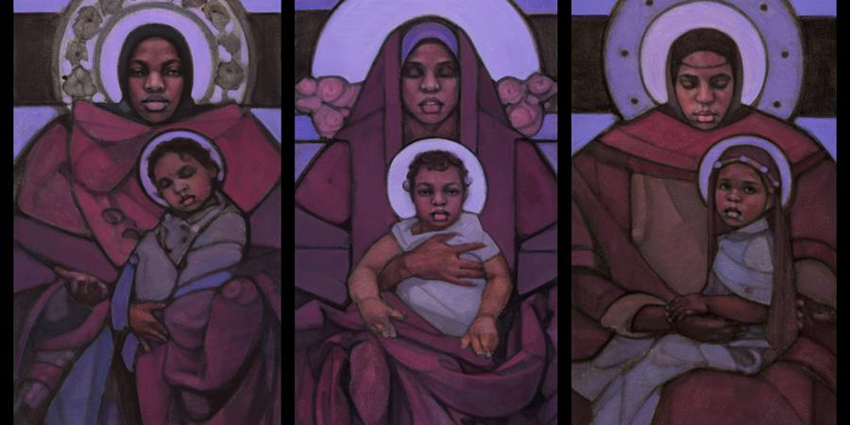

A Lifetime Commitment
Wednesday, December 9, 2020

My dear friend Ronald Rolheiser, O.M.I. reminds us that giving birth spiritually is a dynamic and creative process. To bring Christ into the world involves an ongoing commitment to growth, to discomfort, to love, and to surrender. It is not for the faint of heart, but it is God’s invitation to all of us.
Looking at how Mary gave birth to Christ, we see that it’s not something that’s done in an instant. Faith, like biology, also relies on a process that has a number of distinct, organic moments. What are these moments? What is the process by which we give birth to faith in the world?
First, like Mary, we need to get pregnant by the Holy Spirit. We need to let the word take such root in us that it begins to become part of our actual flesh.
Then, like any woman who’s pregnant, we have to lovingly gestate, nurture, and protect what is growing inside us until it’s sufficiently strong so that it can live on its own, outside us. . . .
Eventually, of course, we must give birth. . . .
Birth, however, is only the beginnings of motherhood. Mary gave birth to a baby, but she had to spend years nurturing, coaxing, and cajoling that infant into adulthood. The infant in the crib at Bethlehem is not yet the Christ who preaches, heals, and dies for us. . . .
Finally, motherhood has still one more phase. As her child grows, matures, and takes on a personality and destiny of its own, the mother, at a point, must ponder (as Mary did). She must let herself be painfully stretched in understanding, in not knowing, in carrying tension, in letting go. She must set free to be itself something that was once so fiercely hers. The pains of childbirth are often gentle compared to this second wrenching.
All of this is what Mary went through to give Christ to the world: Pregnancy by the Holy Spirit; gestation of that into a child inside of her; excruciating pain in birthing that to the outside; nurturing that new life into adulthood; and pondering, painfully letting go so that this new life can be its own, not hers. . . .
Our task too is to give birth to Christ. Mary is the paradigm for doing that. From her we get the pattern: Let the word of God take root and make you pregnant; gestate that by giving it the nourishing sustenance of your own life; submit to the pain that is demanded for it to be born to the outside; then spend years coaxing it from infancy to adulthood; and finally, during and after all of this, do some pondering, accept the pain of not understanding and of letting go.
Christmas isn’t automatic, it can’t be taken for granted. It began with Mary, but each of us is asked to make our own contribution to giving flesh to faith in the world.

