Richard Rohr's Daily Meditation
From the Center for Action and Contemplation
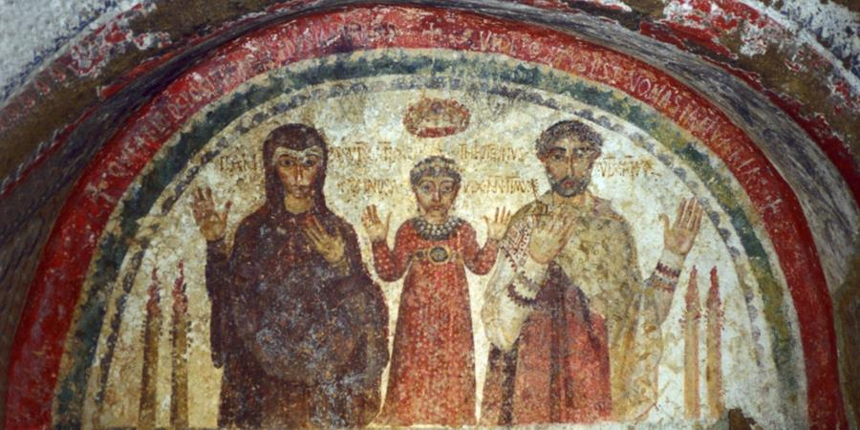

Week Forty-eight
Spirituality and Social Movements

A Faith Created by Courageous Movements
Monday, November 30, 2020

In his book We Make the Road by Walking, my friend and colleague Brian McLaren describes some of the Spirit-led movements that shaped Judaism from the time of Moses, and sustained Christianity. We must remember that such movements are not simply a past occurrence, but something in which we are called to participate in our own time.
I believe that the Spirit of God works everywhere to bring and restore aliveness—through individuals, communities, institutions, and movements. Movements play a special role. In the biblical story [of Exodus], for example, Moses led a movement of liberation among oppressed slaves. They left an oppressive economy, journeyed through the wilderness, and entered a promised land where they hoped to pursue aliveness in freedom and peace. Centuries after that, the Hebrew prophets launched a series of movements based on a dream of a promised time . . . a time of justice when swords and spears, instruments of death, would be turned into plowshares and pruning hooks, instruments of aliveness [Isaiah 2:4; Micah 4:3]. Then came John the Baptist, a bold and nonviolent movement leader who dared to challenge the establishment of his day and call people to a movement of radical social and spiritual rethinking. . . .
When a young man named Jesus came to affiliate with John’s movement through baptism, John said, “There he is! He is the one!” Under Jesus’ leadership, the movement grew and expanded in unprecedented ways. . . . It rose again through a new generation of leaders like James, Peter, John, and Paul, who were full of the Spirit of Jesus. They created learning circles in which activists were trained to extend the movement locally, regionally, and globally. Wherever activists in this movement went, the Spirit of Jesus was alive in them, fomenting change and inspiring true aliveness. . . .
[Christianity] began as a revolutionary nonviolent movement promoting a new kind of aliveness on the margins of society. . . . It claimed that everyone, not just an elite few, had God-given gifts to use for the common good. It exposed a system based on domination, privilege, and violence and proclaimed in its place a vision of mutual service, mutual responsibility, and peaceable neighborliness. It put people above profit, and made the audacious claim that the Earth belonged not to rich tycoons or powerful politicians, but to the Creator who loves every sparrow in the trees and every wildflower in the field. It was a peace movement, a love movement, a joy movement, a justice movement, an integrity movement, an aliveness movement.

Gateway to Action & Contemplation:
What word or phrase resonates with or challenges me? What sensations do I notice in my body? What is mine to do?
Prayer for Our Community:
O Great Love, thank you for living and loving in us and through us. May all that we do flow from our deep connection with you and all beings. Help us become a community that vulnerably shares each other’s burdens and the weight of glory. Listen to our hearts’ longings for the healing of our world. [Please add your own intentions.] . . . Knowing you are hearing us better than we are speaking, we offer these prayers in all the holy names of God, amen.
Listen to Fr. Richard read the prayer.
Story from Our Community:
My practice partners and I run a small free health clinic in a large metropolitan area. Constantly we're confronted with situations that the health 'system' just hasn't been designed to manage. Our mantra has become that the health system isn't broken, it's working just the way it was designed: without consideration for the poor and disenfranchised. . . Suppose, just suppose, we allow the imagination of Jesus to take on the U.S. health system, without ever mentioning the name Jesus, but totally acting in the name of Jesus by putting on the mind of Christ. The compassion, the care, the love exuded by such action could change the world. —Butch P.
Share your own story with us.

Brian D. McLaren, We Make the Road by Walking: A Year-Long Quest for Spiritual Formation, Reorientation, and Activation (Jericho Books: 2015), xvii–xix.
Image credit: Catacombe Di San Gennaro (detail of the fresco of the Catacomb of Saint Gennaro), paleo-Christian burial and worship sites, Naples, Italy.

